RWF Learning Management System (LMS)
Product Requirement Document (PRD)
Product Manager: Vinay Kumar Adalath
Version: V1.3
Date: 26 Feb 2026

1. Vision & Strategic Purpose
- Community Empowerment: Equip youth and women from underserved communities with employable and entrepreneurial skills.
- Institutional Strengthening: Standardize onboarding, training, and monitoring for interns, staff, and coordinators.
- Outcome Focus: Move beyond training completion to measurable livelihood outcomes (employment, income growth, self-employment).

2. Target Beneficiaries
- Community: Freshers, women seeking livelihood skills, youth with limited employability exposure
- Internal Stakeholders: Field staff, trainers, coordinators, program associates, volunteers, interns

3. Core Challenges Addressed
- Low employability and skill gaps
- Absence of structured onboarding
- Inconsistent delivery quality
- Limited digital and professional exposure

4. Program Structure
- Skill-Based Training (computers, stitching, beauty, design)
- Role-Based Training (coordinators, trainers, managers)
- Department-Based Training (education, environment, skilling, operations)

5. Duration & Learning Phases
- Short-term: 1–3 months
- Advanced: 3–6 months
- Internships: 2–6 months
- Phases: Orientation → Core modules → Practical assignments → Assessment → Certification → Career guidance

6. Cohort & Intake Model
- Cohort-based batches (3–6 months)
- Rolling intake for foundation/digital modules
- Bulk enrollment & waitlist handling

7. Training Delivery Formats
- Instructor-led classroom sessions
- Practical labs
- Self-paced digital modules
- Hybrid (recorded + live sessions)
- Multilingual support (Hindi, Bengali, Assamese, English) – TBD

8. Learning Pathways
- Computer Track: Basic → Advanced → Graphic/UI/UX
- Stitching Track: Basic → Advanced → Production & Market Linkage

9. Assessments & Certification
- MCQs (auto-graded)
- Practical assignments (trainer graded)
- Case studies & live projects
- Hybrid grading
- Certification: RWF + CSR partners, non-expiring, QR verification – TBD

10. KPIs & Success Metrics
- Course completion rate
- Attendance percentage
- Assessment score improvement
- Certification rate
- Placement & internship conversion
- Beneficiary income growth

11. Monitoring & Alerts
- Metrics: Attendance, module completion, assignment status, dropout rate
- Alerts: Low attendance, missed deadlines, poor performance, dropout risk

12. Enrollment & Data Management
- Enrollment: Beneficiaries via centers, interns via approval, staff via managers
- Data stored: Personal details, education, socio-economic info, attendance, scores, certification, placement/income tracking
- Retention: 5–7 years

13. Post-Training & Career Transition
- On-Job Training (OJT) at RWF centers or partners
- Career transition: Jobs, production units, self-employment
- Impact tracking: Placement monitoring, income growth, entrepreneurship

14. Technology & Operational Requirements
- Web-first platform, mobile app (future)
- Integrations: Zoom/Meet, SMS/WhatsApp, APIs
- Compliance: India DPDP Act, audit trails, anonymized reporting
- Scalability: Multi-center expansion, growth projections – TBD
- Operational model: LMS ownership, vendor vs in-house IT, SLAs – TBD

15. Risks & Assumptions
- Assumptions: NGO scaling, donor reporting critical, placement tracking mandatory
- Risks: Poor digital adoption, incomplete placement data, privacy non-compliance, over-customization

16. MVP Scope (Phase 1)
- Enrollment & batch management
- Attendance tracking
- Assessments & grading
- Certification generation
- Basic dashboards
- Placement tracking

📌 Feature Roadmap by MVPs
MVP1: Enrollment & Batch Allocation
- Center registration
- Management approval (interns)
- Bulk enrollment
- Waitlist handling
- Batch creation & allocation
MVP2: Attendance & Lifecycle Tracking
- Attendance logging
- Module completion tracking
- Assignment submission
- Dropout monitoring
- Alerts triggered
MVP3: Assessments & Certification
- MCQ auto-grading
- Practical assignments
- Case studies/live projects
- Hybrid grading
- Certificate generation
MVP4: Placement & Career Transition
- Internship tracking
- Employment conversion
- Income growth monitoring
- Entrepreneurship setup tracking
- OJT workflow
MVP5: Analytics & Donor Dashboard
- KPI dashboards
- Donor/CSR dashboards
- Export formats
- Role-based visibility
- Data anonymization
MVP6: Technology & Scalability Enhancements
- Web-first platform
- Mobile app (future)
- Integrations (Zoom/Meet, SMS/WhatsApp, APIs)
- Compliance (DPDP Act)
- Multi-center scaling
- Backup & recovery

📊 Flow Diagrams (Insert Images Here)
- Overall LMS Lifecycle
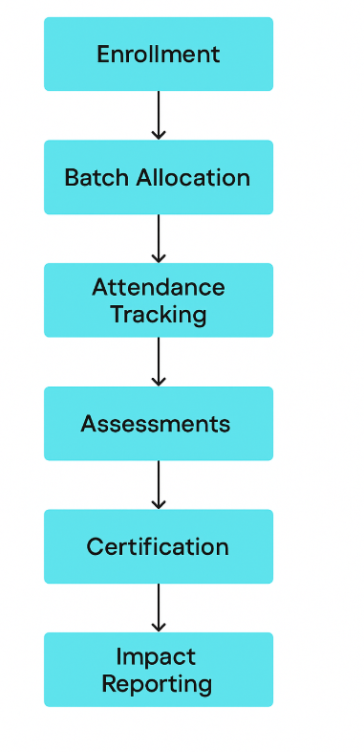
- MVP1: Enrollment & Batch Allocation
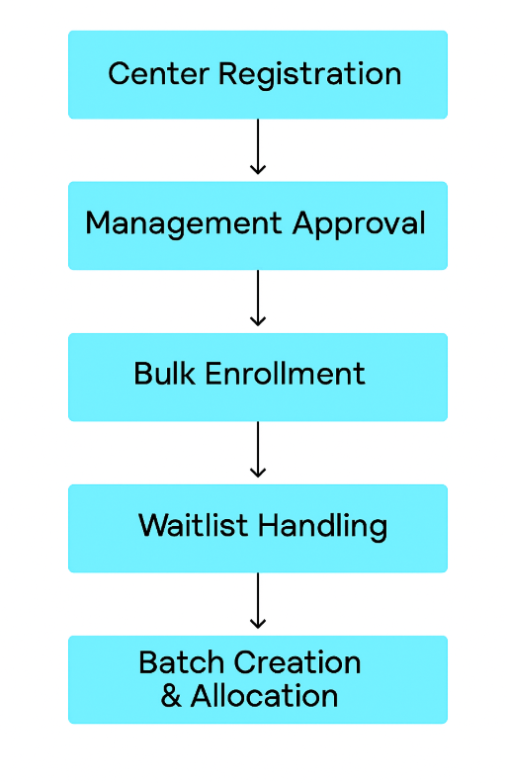
- MVP2: Attendance & Lifecycle Tracking
- MVP3: Assessments & Certification
- MVP4: Placement & Career Transition
- MVP5: Analytics & Donor Dashboard
- MVP6: Technology & Scalability Enhancements

👉 Copy this into Word, insert the flow diagrams we created earlier into the placeholders, and save as .docx. You’ll then have a complete PRD document ready for your dev team.
Would you like me to now prepare the user stories document separately in the same structured format so you’ll have both files ready?

